**SSL Certificate renewal steps,** (for web servers only ssl is there)

* First we have to backup in server in which we are going to do certificate renewal. For that login to that server through particular(wcs,oms,cto,wesb) build server as wcsuser,
* For c0006107,(Build servers ask username & password for wcsuser)

Wcsuser  
EtrProd#@741

Sample server,

Ssh g1t2999g.austin.hp.com

cd /opt/apps/IBM/HTTPServer/conf



Take backup of above three latest files. (cp filename bkp_filename)

Renew the SSL cert

* 1. Login to the HIS(web) server as wcsuser. For load balanced certs, log in to one of the IHS servers. Path: /home/wcsuser

./renewssl.sh

It will ask password **Ecommerce@2016**

* 1. At the first prompt asking for the installation path just hit ENTER
  2. At the next prompt,
     1. If this SSL cert is for a **single server**, enter the server FQDN (Ex. **c0008101.itcs.hp.com**).
     2. If this server is**load balanced**, enter the full FQDN of the load balancer. (Ex. **glbecomtran-wcsweb-dev7.glb.itcs.hp.com**)
  3. At the next prompt, enter the short name of the FQDN above. (**c0008101** or **glbecomtran-wcsweb-dev7**)

Give password When it prompts.

* 1. Next, you should see the path to the httpd.conf file which should be /opt/apps/IBM/HTTPServer/conf. Hit ENTER.

Refer the below screenshots for above mentioned steps,

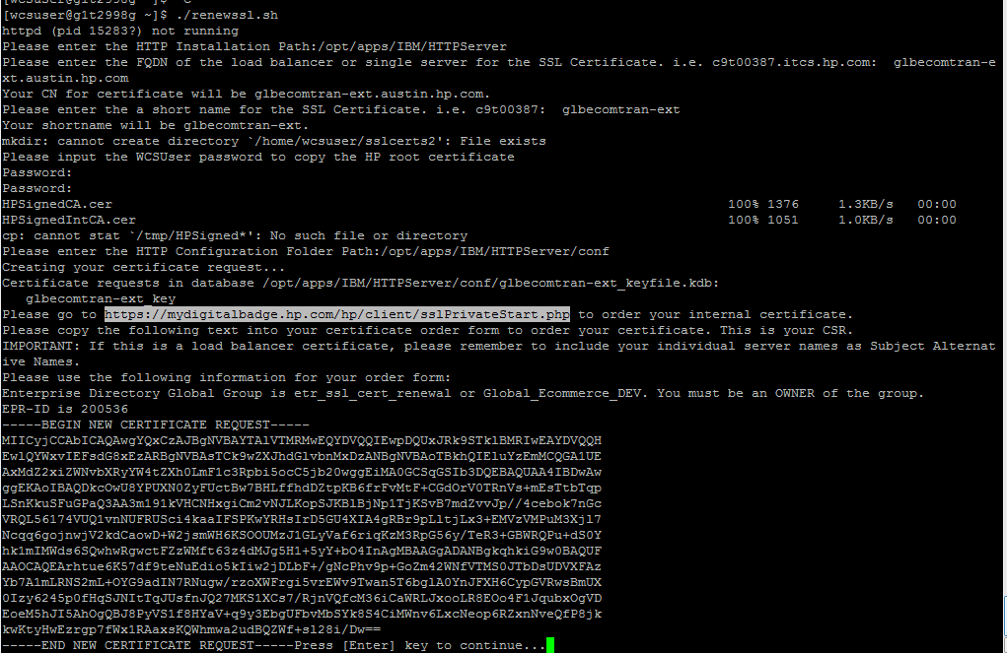

* 1. Follow the on screen instructions. Go to this link <https://mydigitalbadge.hp.com/hp/client/sslPrivateStart.php> and fill out all the information.

Please find the screenshot below and fill the details as per mentioned in the screenshot

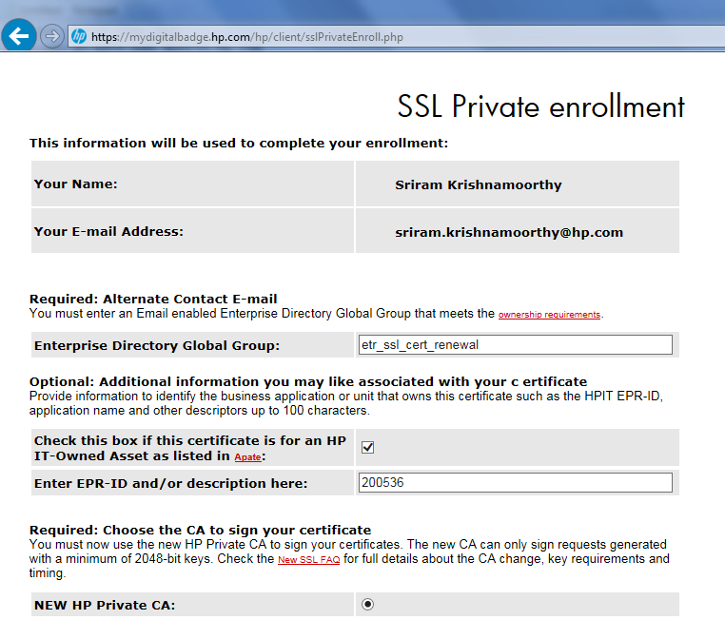

Below Is example of certificate key generation you give the details according to what you have generated: (in the server we are working copy in putty and paste here and server names you are going to do ssl)

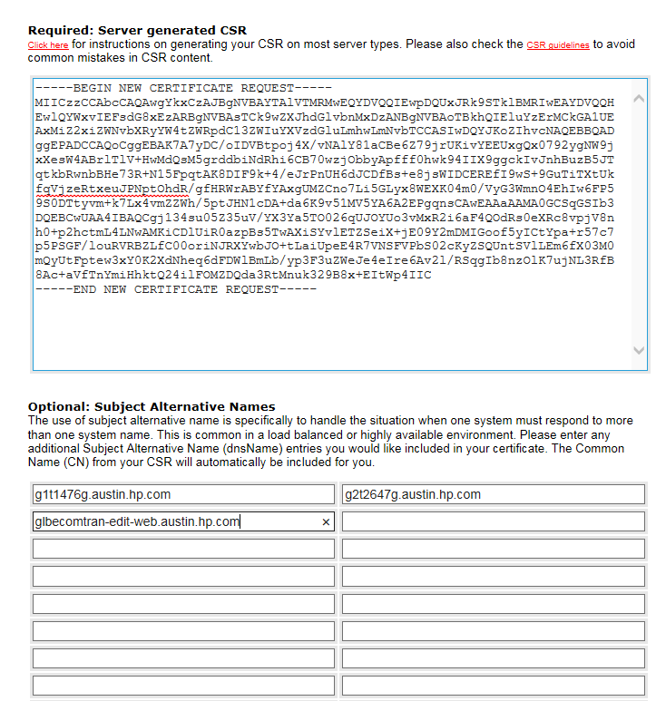

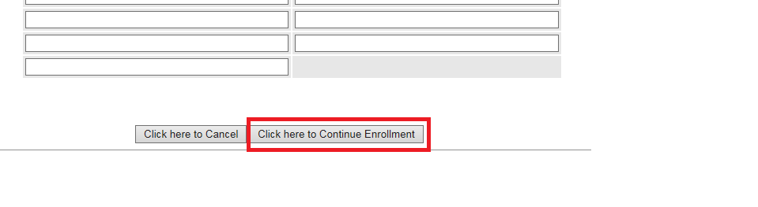

In Next page:

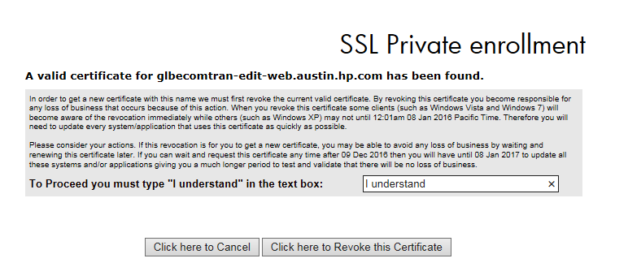

Copy the certificate from this below page and paste it in Unix box:

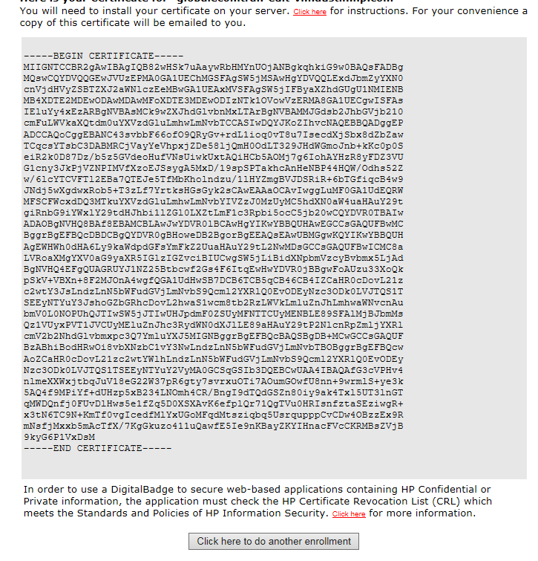

Copy this key to putty server where we are working,

After pasting this in Unix server press “ctrl D” twice and it will create certificate key files in /opt/apps/IBM/HTTPServer/conf folder, copy the three key files to other web servers in path: /opt/apps/IBM/HTTPServer/conf.

Last step:  Restart web servers.

To restart web servers follow screenshot steps,

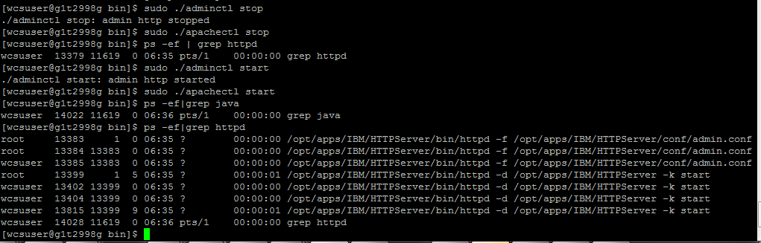

And please check the site for latest SSL certificate date and expiry.

Note: Check in folder for latest file.

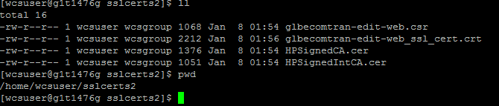

Below can be checked by, (For sample server)

https: g1t2999g.austin.hp.com( click on https lock symbol)

